Flow Name: Send NPS Mail – Automated Survey & Follow-Ups

Problem:
Customer feedback via NPS surveys needs to be collected at the right time in the client lifecycle and followed up consistently when responses are not received. Manually tracking when to send surveys and follow-ups leads to missed feedback, inconsistent timing, and additional operational effort.

Solution:
This automation uses Google Sheets as the system of record for NPS tracking and Gmail as the communication channel. It automatically sends the initial NPS survey email and subsequent follow-up emails based on defined date conditions, while updating the tracking sheet to reflect send and follow-up timelines.
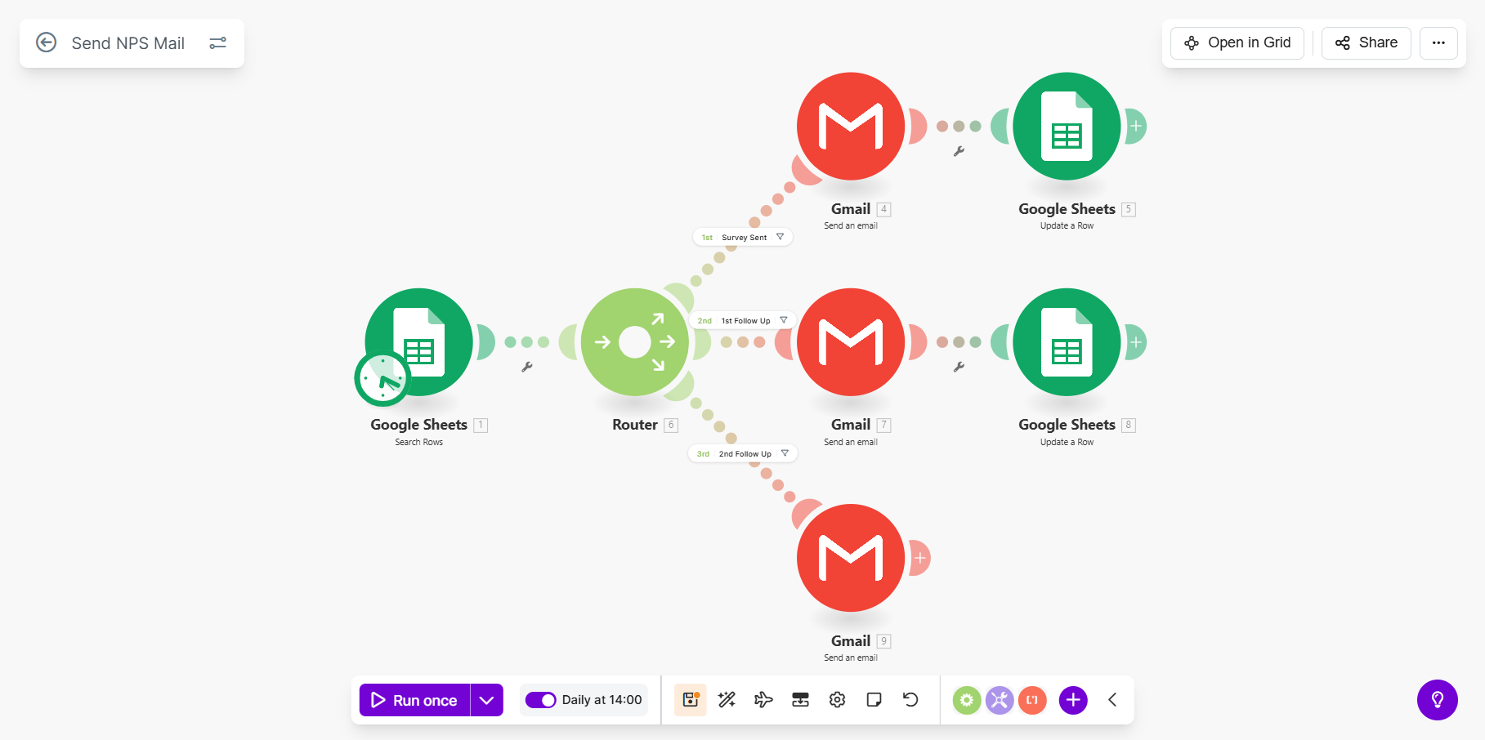
Flow Details:
Step 1: Load Eligible NPS Records from Google Sheets
The automation retrieves rows from the NPS first message Google Sheet using the Filter Rows module.
Only rows where the Email Address column exists are considered, and rows are sorted by row number in descending order to process the most recent entries first.
Step 2: Router – Determine NPS Communication Stage
A router evaluates each row to determine which action should be taken based on date fields, rating status, and prior email activity. This allows the flow to handle initial survey emails and follow-ups within a single automation.
Step 3: Send Initial NPS Survey Email
If at least three months have passed since the client’s starting date, an email address exists, and no “Date Sent” value is present, the automation sends the initial NPS survey email to the client using Gmail.
Step 4: Update Sheet After Initial NPS Email
After sending the initial survey email, the automation updates the Google Sheet row by:
- Setting the Date Sent column to the current date
- Setting the Follow-up Date column to seven days in the future
This establishes the schedule for follow-up communication.
Step 5: Send First Follow-Up Email
If the initial survey email has been sent, a follow-up date exists, the current date is equal to or later than the follow-up date, and no rating has been recorded, the automation sends the first follow-up NPS email.
Step 6: Update Sheet After First Follow-Up
After sending the first follow-up email, the automation updates the 2nd Follow-Up date column to thirty days in the future to schedule the next follow-up.
Step 7: Send Second Follow-Up Email
If the second follow-up date exists, the current date has reached or passed that date, and no rating has been recorded, the automation sends the second follow-up NPS email to the client.

Overall Flow Summary:
This automation establishes a fully automated NPS outreach process using Google Sheets as the tracking layer and Gmail as the delivery mechanism. By dynamically determining when to send initial surveys and follow-ups and by updating tracking fields after each action, the flow ensures consistent feedback collection, eliminates manual tracking, and improves response rates over time.

